**GLOBAL STATISTICAL MAPPING**

**OF COVID-19**

**by-SIMRAN**

**The Global Mapping project is an international collaborative initiative through voluntary participation by national mapping organizations of the world, aiming to develop a globally homogeneous geographic data set at the ground resolution of 1km. Basically in simple terms, it means that to collect data or information which describes the present status of the global environment.**

**WHO conducted a survey globally and reported that there have been 84,233,579 confirmed cases of COVID-19, including 1,843,293 deaths since the outburst of the pandemic.**

**The below dashboard gives a clear picture of the covid-19 outburst globally.**

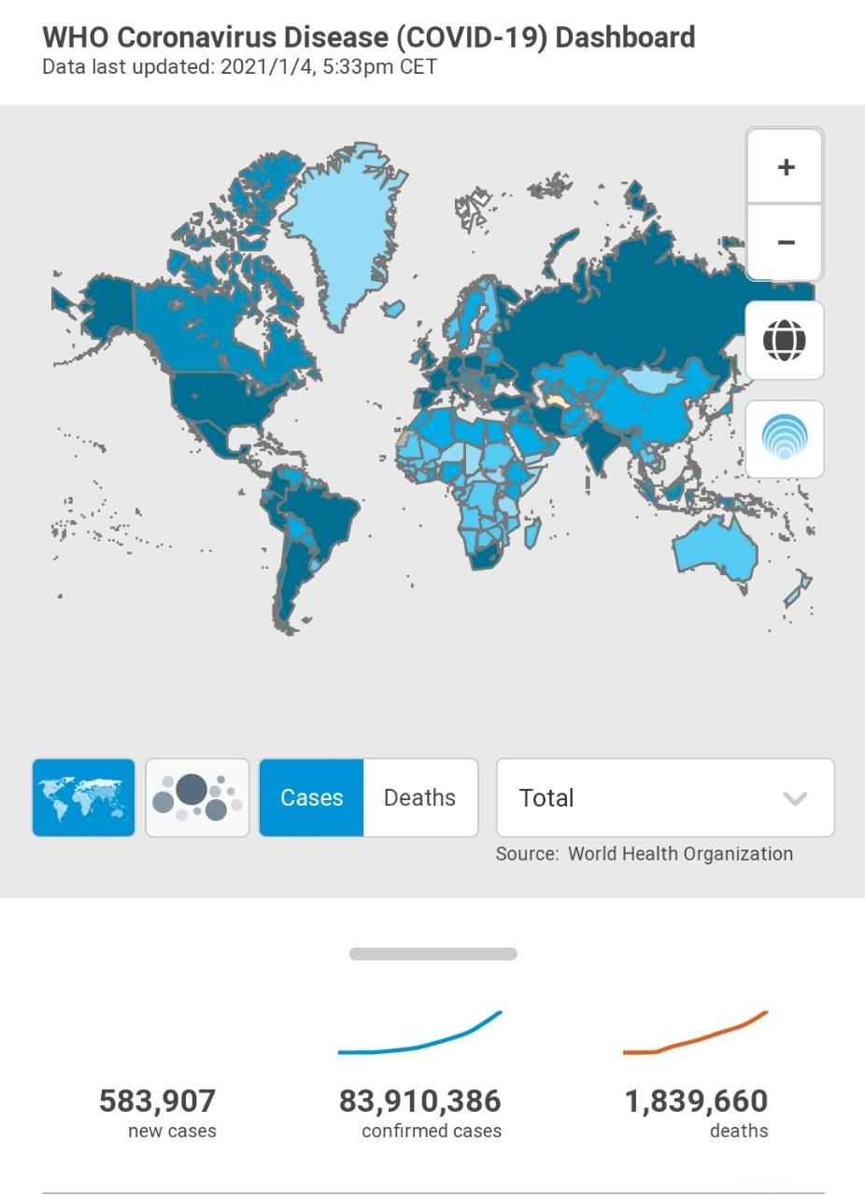

**At the commencement of the epidemic, The World Health Organization (WHO) had exhorted that the virus will subsist to spread rapidly in the approaching months, and slowly there will be a speedy escalation in the figure of cases confirmed with infection being more than 85 million people and took away more than 1.8 million globally resulting in innumerable countries took major steps such as nations effectuating lockdowns, which ultimately shattered financial markets.**

**But after taking measures the figure of cases increased day by day and the affected countries couldn't control the state of affairs at the global rate.**

**We can clearly see how the cases increase day by day after taking several measures to circumvent the escalation of the fatal virus but it failed.**

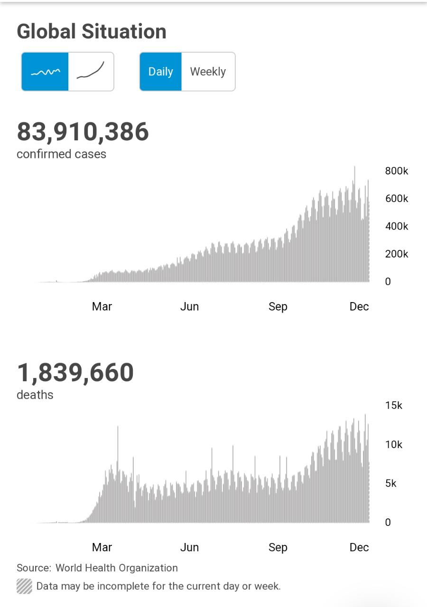

* **Asia was the center of the start of the outbreak, but America became the center of the rife and slowly it spread in the nearby countries and adversely affected the lives of the people.**
* **India being the second country in population it has set down more than 10 million cases, officially scoring the second-highest position in the world after the US, eventually the number went down since lockdown was imposed.**
* **In Latin America, Brazil stands second highest in the mortality toll with about 8 million confirmed cases. The second wave too has approached the country.**
* **The current concern is with regards to the South African mutant of the disease which is found to share its analogy with the new UK strain, including being more easily transmissible.**
* **South Africa, which has cases of more than one million and nearly 30,000 deaths, is the worst affected country on the global level.**
* **African countries such as Libya, Morocco, Ethiopia, Egypt, and Tunisia, have officially recorded more than 100,000 cases.**

**SITUATION BY COUNTRY, TERRITORY OR AREA**

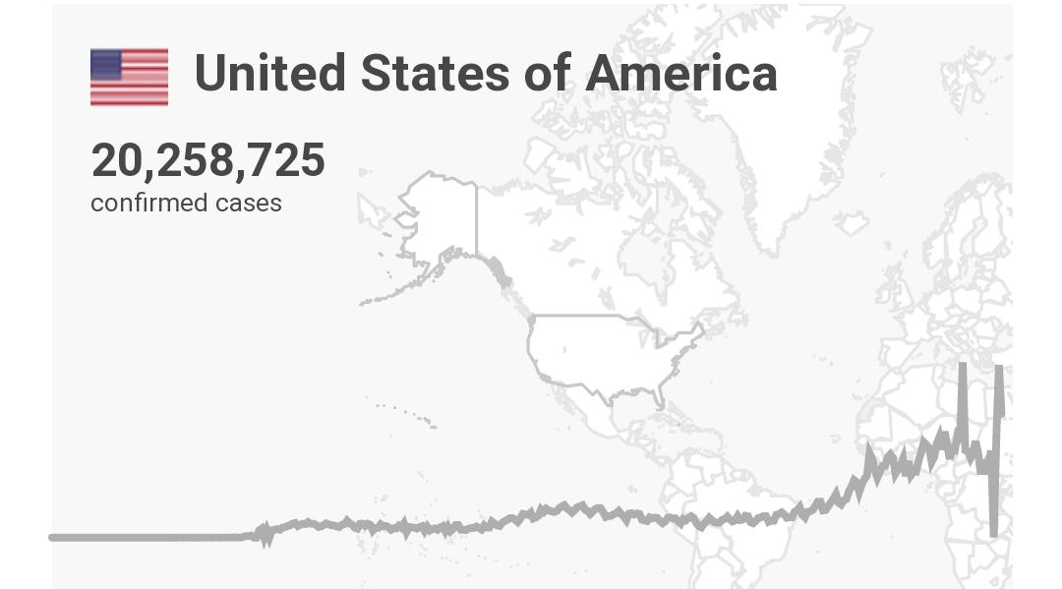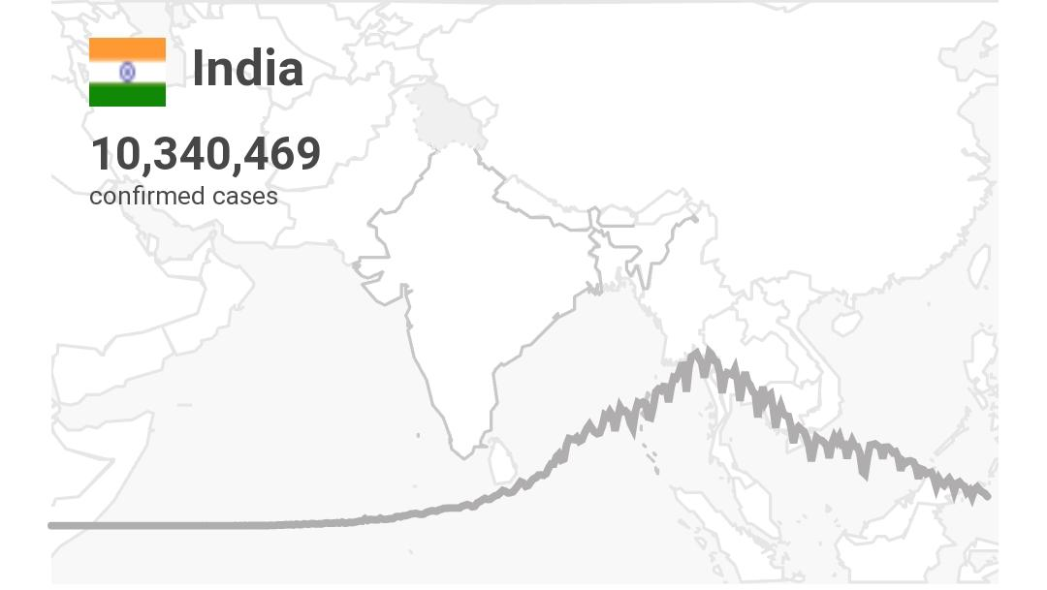

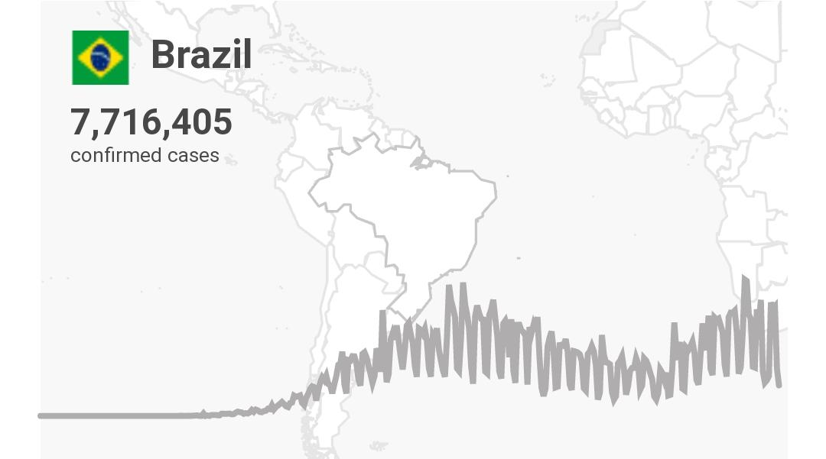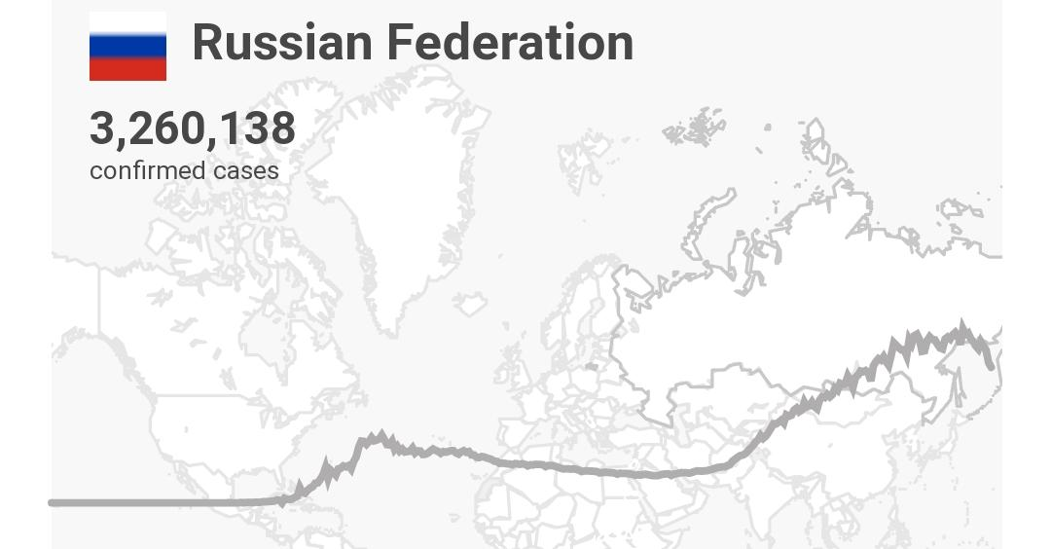

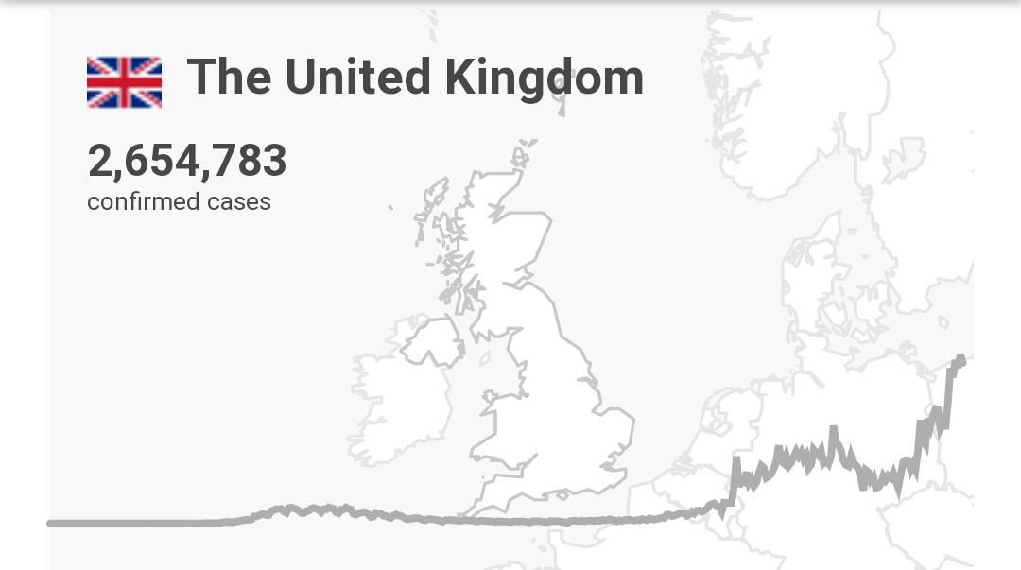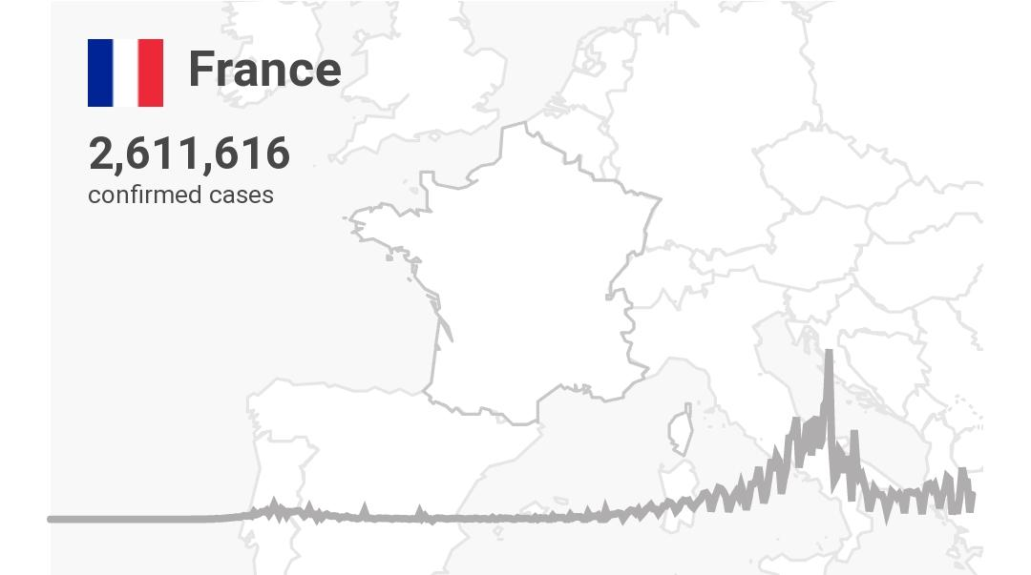

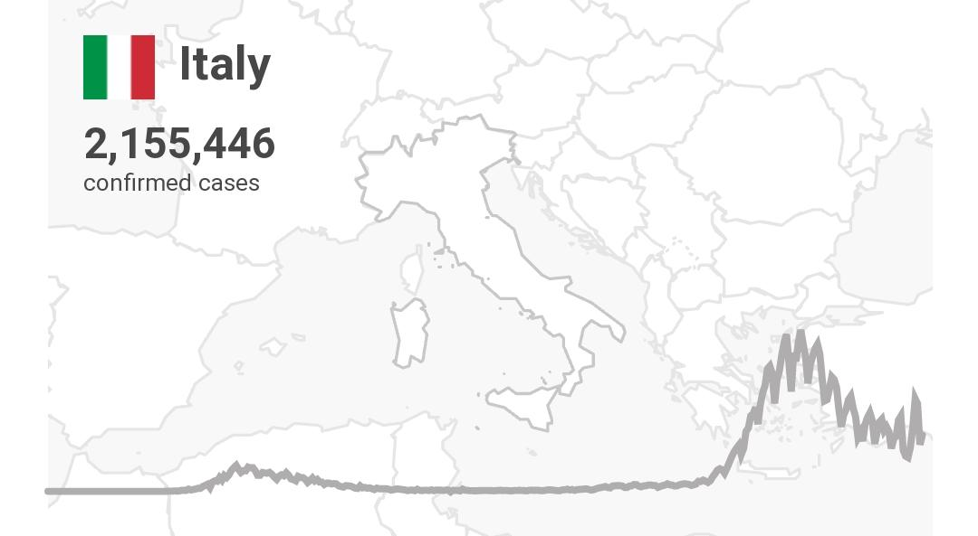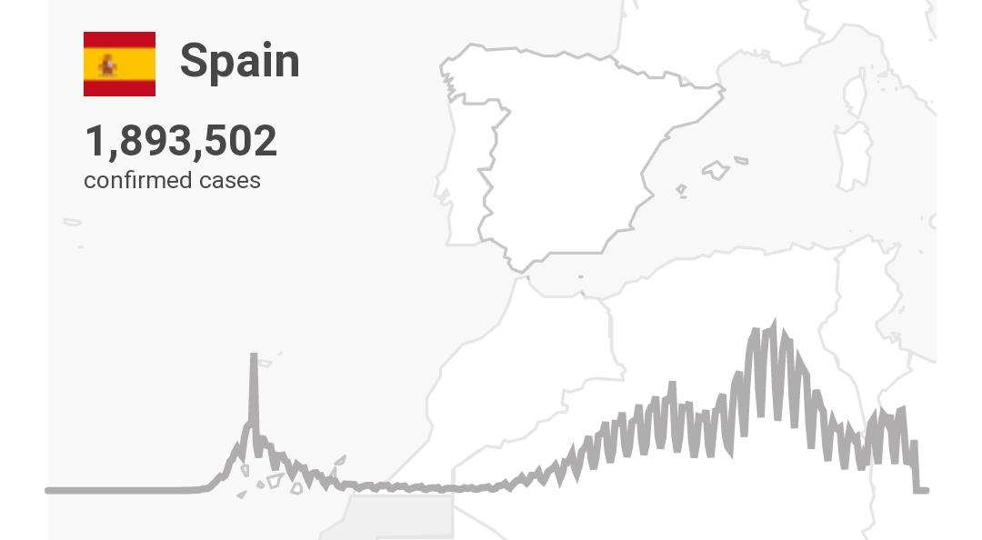

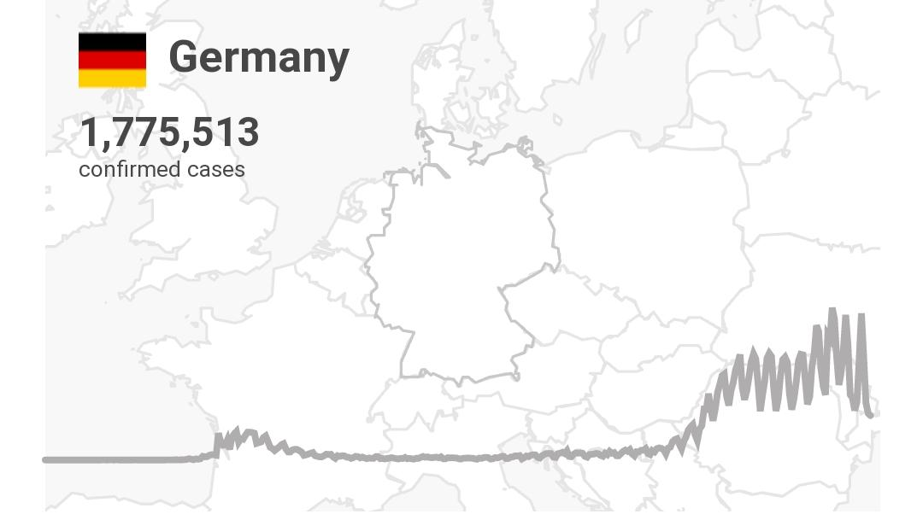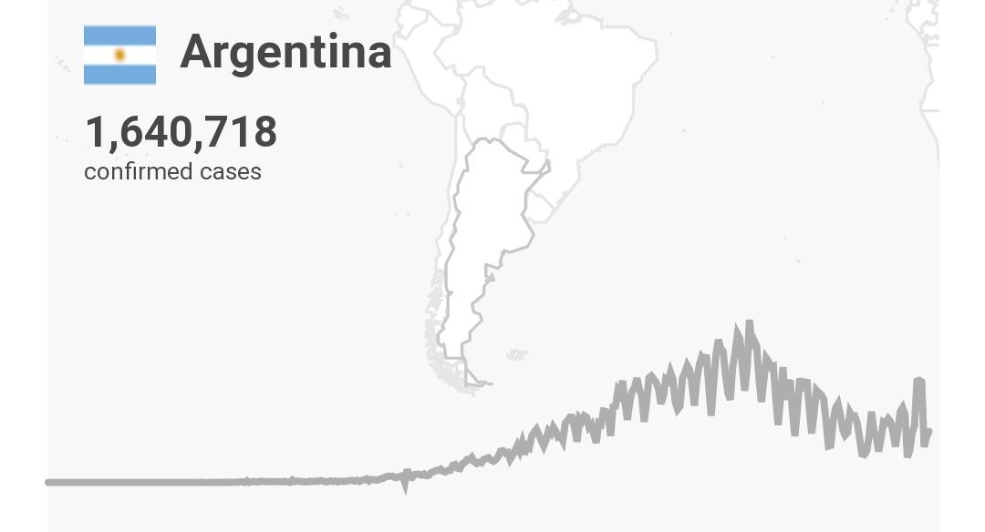

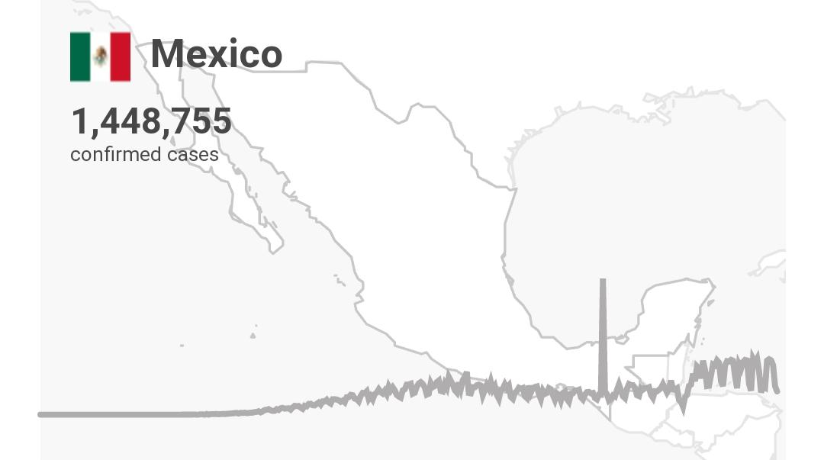

References:

### [**WHO Coronavirus Disease (COVID-19) Dashboard | WHO ...**](https://covid19.who.int/)

* [covid19.who.int](https://covid19.who.int/)

### [**Coronavirus Pandemic (COVID-19) - Statistics and Research ...**](https://ourworldindata.org/coronavirus)

* [ourworldindata.org › coronavirus](https://ourworldindata.org/coronavirus)

### [**Covid-19 pandemic: Tracking the global coronavirus outbreak ...**](https://www.bbc.com/news/world-51235105)

* [www.bbc.com › news › world-51235105](https://www.bbc.com/news/world-51235105)

### [**Global COVID-19 | CDC**](https://www.cdc.gov/coronavirus/2019-ncov/global-covid-19/index.html)

* [www.cdc.gov › coronavirus › 2019-ncov › global-covi...](https://www.cdc.gov/coronavirus/2019-ncov/global-covid-19/index.html)